Parents’ Guide to Student Success in *Mathematics*

*Second Grade*

**Why Are Academic Standards Important?**

Academic standards are important because they help ensure that all students, no matter where they live, are prepared for success in college and the workforce. Standards provide an important first step — a clear roadmap for learning for teachers, parents, and students. Having clearly defined goals helps families and teachers work together to ensure that students succeed. They also will help your child develop critical thinking skills that will prepare him or her for college and career.

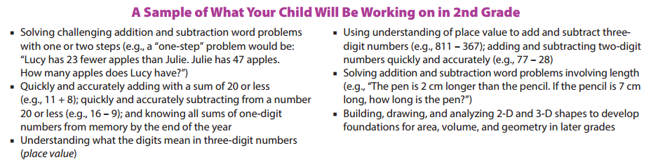

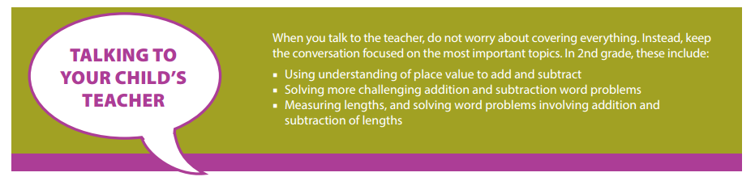

**Help Your Child Learn at Home**

Try to create a quiet place for your child to study, and carve out time every day when your child can concentrate. You should also try to sit down with your child at least once a week for 15 to 30 minutes while he or she works on homework. This will keep you informed about what your child is working on, and it will help you be the first to know if your child needs help with specific topics. Additionally, here are some activities you can do with your child to support learning at home:

*Look for “word problems” in real life. Some 2nd grade examples might include:*

* When saving for a purchase, compare the cost of the item to the amount of money you have; then ask your child to determine how much more money he or she needs to buy the item.
* Play “draw the shape.” For example, ask your child to draw a hexagon with one side longer than the others, or ask him or her to shade in a quarter of a rectangle.

Resource: <http://www.pta.org/parents/>

**Second Grade**

Nine Week Checkpoints for Parents and Students



|  |  |
| --- | --- |
| **First Nine Weeks** | **Second Nine Weeks** |
| *Helpful websites to help students master the first and second nine weeks:*  [*https://www.khanacademy.org/commoncore/grade-2-NBT*](https://www.khanacademy.org/commoncore/grade-2-NBT)  [*https://www.khanacademy.org/commoncore/grade-2-OA*](https://www.khanacademy.org/commoncore/grade-2-OA)  [*https://www.khanacademy.org/commoncore/grade-2-MD*](https://www.khanacademy.org/commoncore/grade-2-MD) | |
| *Students should know and be able to:*   * Explain what the three digits of a three-digit number represent (i.e. 706 equal 7 hundreds, 0 tens, and 6 ones) * Read and write numbers to 1000 using numbers, number names, and expanded form * Compare three-digit numbers using symbols (i.e. >, =, and <) * Add and subtract within 100 * **Fluently add and subtract within 20 using mental math1** * **Fluently add and subtract within 100 using strategies** | *Students should know and be able to:*   * Measure the length of objects and compare objects lengths * Estimate length using inches, feet, centimeters, and meters * Solve word problems using lengths that are given in the same units * Use measurements to make a line plot * Represent lengths on a number line * Tell time to the nearest 5 minutes when looking at analog and digital clocks * Write time to the nearest 5 minutes using a.m. and p.m. * Add and subtract two-step word problems |
| **Third Nine Weeks** | **Fourth Nine Weeks** |
| *Helpful websites to help students master the third and fourth nine weeks:*  [*https://www.khanacademy.org/commoncore/grade-2-MD*](https://www.khanacademy.org/commoncore/grade-2-MD)  [*https://www.khanacademy.org/commoncore/grade-2-G*](https://www.khanacademy.org/commoncore/grade-2-G)  [*https://www.khanacademy.org/commoncore/grade-2-OA*](https://www.khanacademy.org/commoncore/grade-2-OA) | |
| *Students should know and be able to:*   * Add up to (4) two-digit numbers * Add and subtract within 1,000 * **Mentally add and subtract 10 or 100 to a given number 100-900** * Recognize and draw 2D and 3D shapes | *Students should know and be able to:*   * Divide a rectangle info rows and columns * Dividing shapes into equal parts * Even and odd numbers * Addition with an array |

1 *By end of year, know with* ***conceptual understanding*** *from memory all sums of two one‐digit numbers.*